Cloud Computing Assignment 8

Name: Om Butala

Roll No: 323071

GR No: 22120149

Batch: C3

Aim

To deploy web application on Kubernetes

# Theory

What are K8's?

1. Kubernetes is an open-source container orchestration system for automating software deployment, scaling, and management.
2. It was originally designed by Google and is now maintained by the Cloud Native Computing Foundation
3. Kubernetes defines a set of building blocks ("primitives") that collectively provide mechanisms that deploy, maintain, and scale applications based on CPU, memory or custom metrics.
4. It is mainly used to automate the deployment, scaling, and operations of container- based applications across a cluster of nodes.

Basics of K8’s?

Some basic concepts of Kubernetes include containers, deployment, ReplicaSet, service, pod, volumes, and namespaces.

Containers: A container is an executable and stand-alone piece of software that includes everything required for running it

Deployment: Deployment is helpful when it comes to making a stateless application that will operate continuously like an HTTP server.

Replica Set: A Replica Set ensures that your application has the required number of Pods

Service: A service provides a stable IP address and DNS name for a set of Pods

Pod: A pod confines application containers, storage resources, a unique network IP, and options that govern how the container(s) should run

Volumes: Volumes are used to store data in a way that can be accessed by multiple containers at once

Namespaces: Namespaces are used to divide cluster resources between multiple users or teams

## Benefits of Kubernetes

Some benefits of using Kubernetes include.

1. Improved productivity owing to the huge ecosystem.
2. Futureproofing, variety of workloads and deployment options
3. Enhanced security, compatibility with major cloud providers
4. Container orchestration savings
5. Increased DevOps efficiency for microservice, greater scalability and flexibility, and portability

## Architecture of Kubernetes

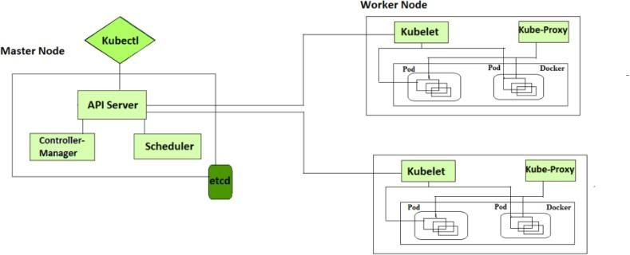

The architecture of Kubernetes consists of several main components:

1. Master Node: The Master node acts as the control center for the cluster, managing the desired state of the cluster and ensuring that the actual state matches the desired state.
2. Worker Nodes: Worker nodes are where your application containers run. They communicate with the Master node to receive instructions and report their status.
3. etcd: etcd is a distributed key-value store that stores the configuration data for the cluster.
4. API Server: The API Server is the main interface for communication between the Master node and the worker nodes. It exposes the Kubernetes API, which can be used to manage the cluster and deploy applications.
5. Controller Manager: The Controller Manager is responsible for running various controllers that regulate the state of the cluster, such as the replication controller and endpoints controller.
6. Scheduler: The Scheduler is responsible for assigning pods to worker nodes based on resource requirements and constraints.
7. kubelet: kubelet is a process running on each worker node that communicates with the Master node to receive instructions and ensure the containers are running as intended.
8. kubectl: kubectl is the command-line interface for interacting with the Kubernetes API.

Note:

## Write the difference between kubectl and kubelets

1. kubectl is the command-line interface (CLI) tool for working with a Kubernetes cluster. It communicates with the API server to perform various operations on the cluster, such as deploying applications, scaling resources, and inspecting logs.

# Deployment steps

Before starting make sure that you have docker installed on your device

## Install Kubernetes

We will be using Choco as it is the package manager of windows

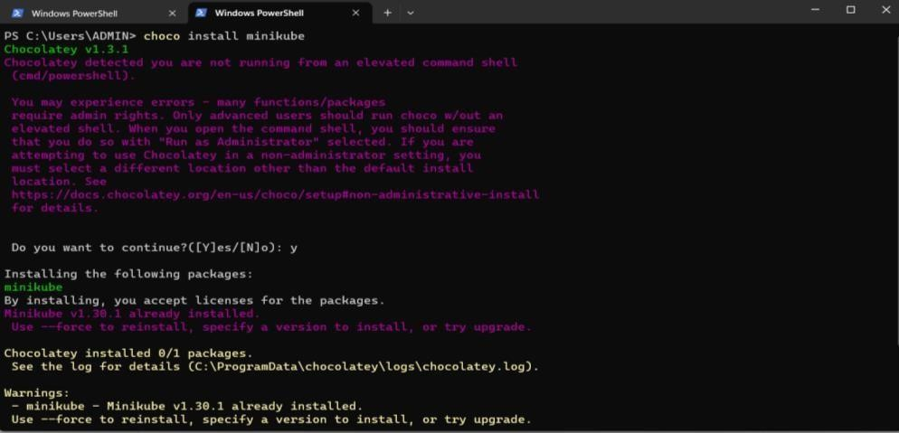

Start the k8’s & go to the dashboard.

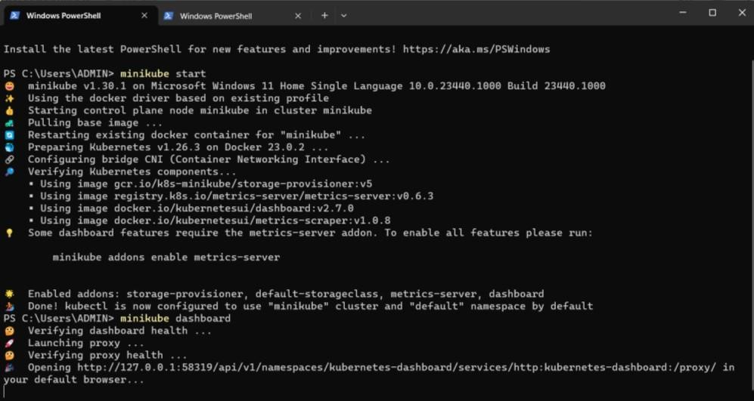

Let’s build & upload textutils image to docker hub.

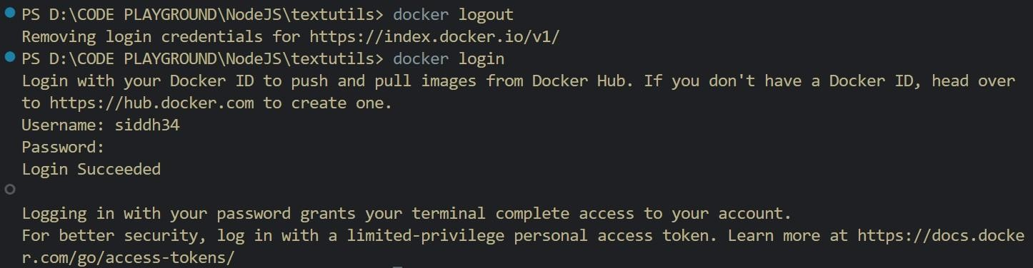

Build the image & tag it like dockerHubUserName/ImageName

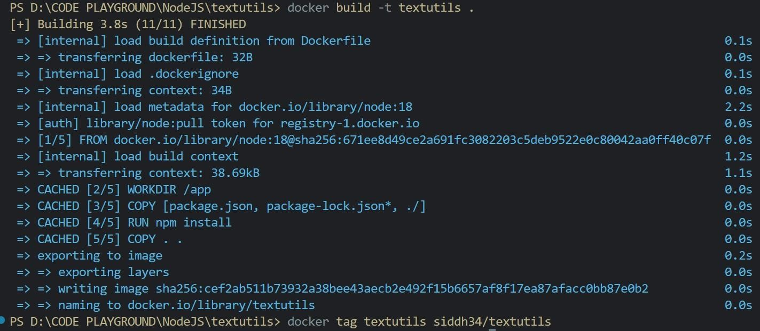

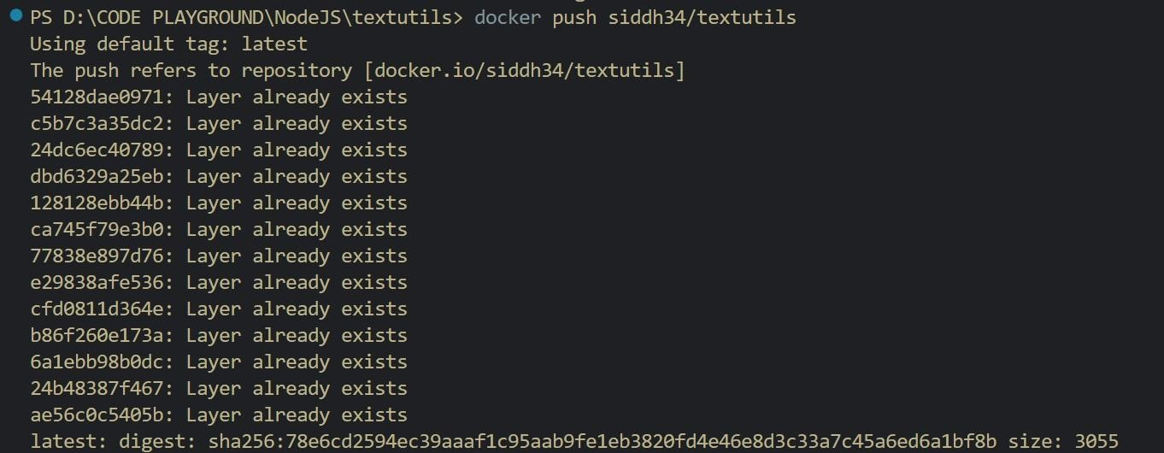

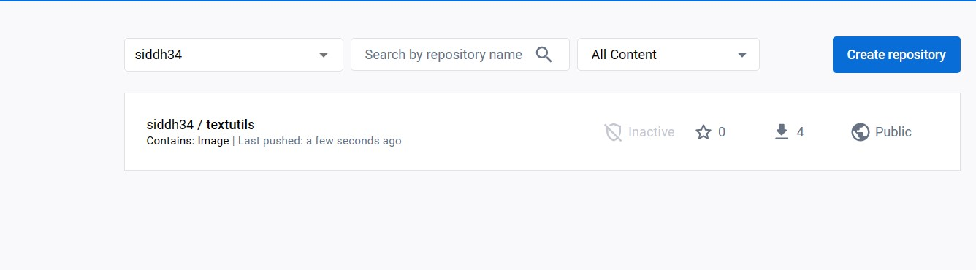

kevin47

/

**textulis**

kevin47

Fill this form by pressing the ‘+’ sign.

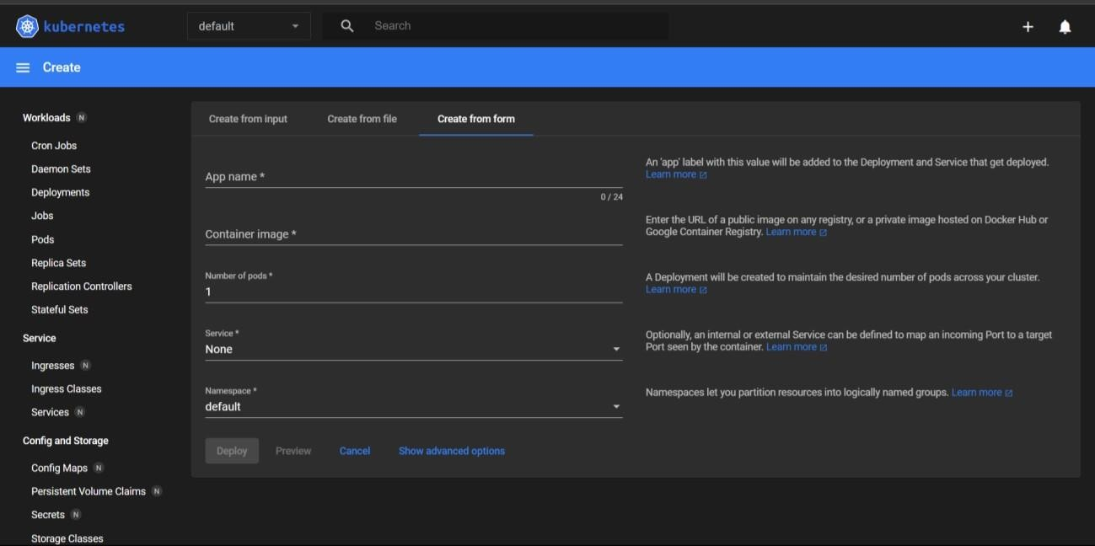

App name → textutils

Container image → siddh34/textutils [refer the docker hub image]

Service → External Port → 8002, target 3000

You will be redirected to this screen.

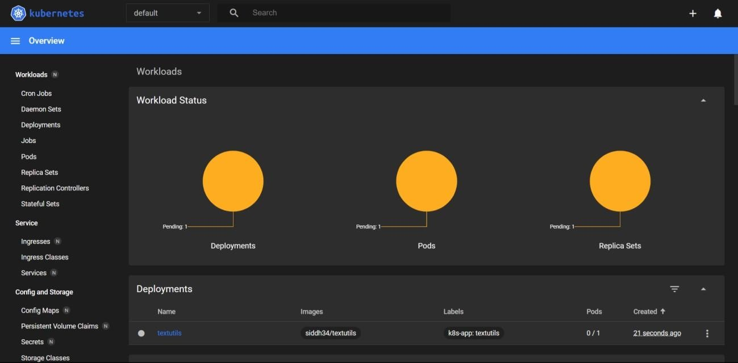

kevin47/textulis

Wait till deployment is done!

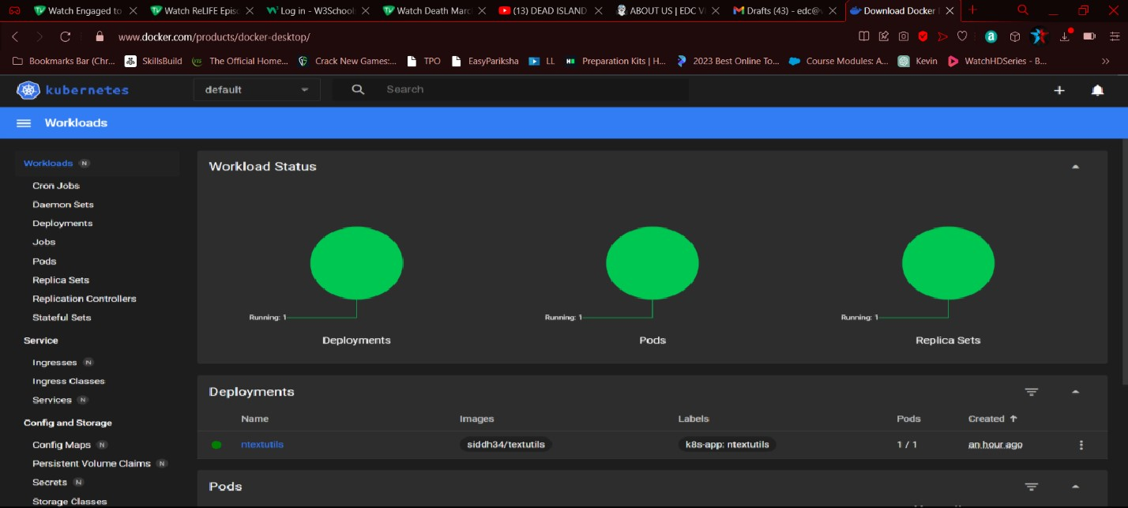

kevin47/textulis

Run the minikube service textutils

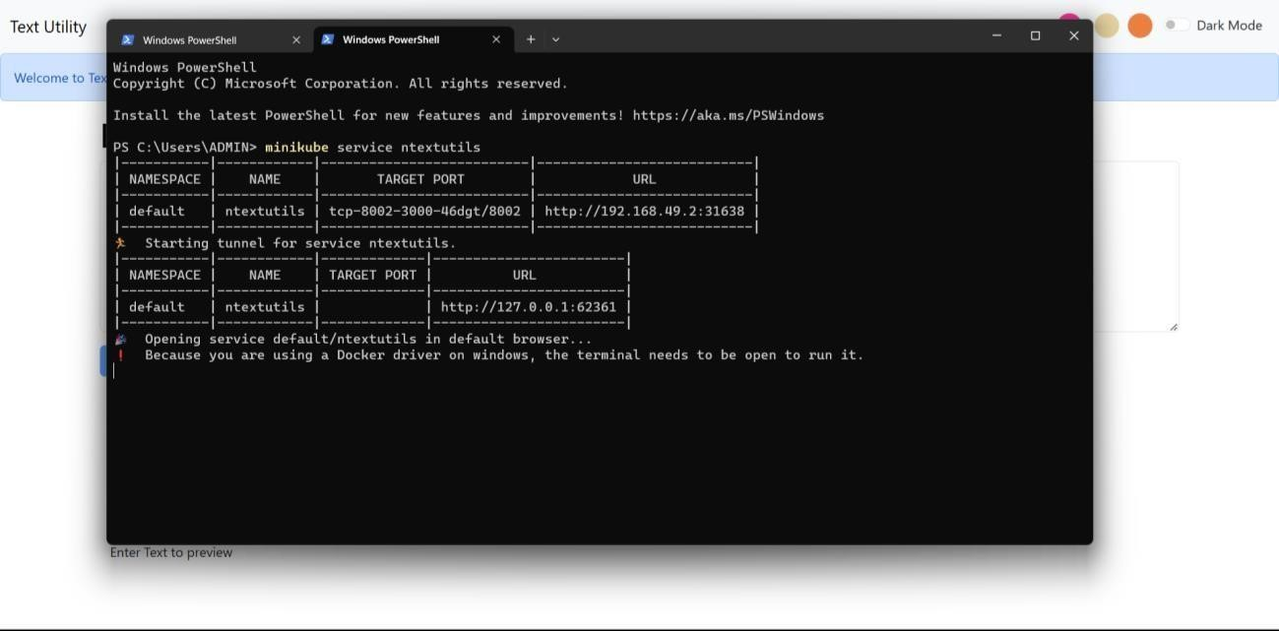

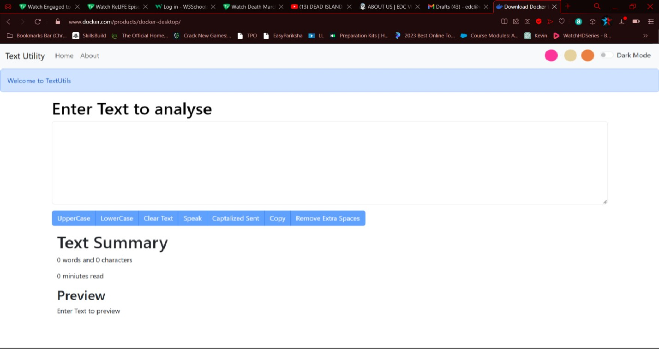

Delete the services

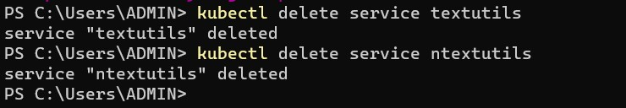

# Conclusion

Kubernetes is understood.